TEMPLATE Letter to send TO clients/main contractors (buyers)
Dear …
I note that I have been asked to be assessed by the [insert name of scheme provider A] Scheme, which is a member scheme within the Safety Schemes in Procurement (SSIP) Forum.
The SSIP Forum’s member schemes all comply with health and safety core assessment criteria which have been recognised by the HSE (and which are consistent with the health and safety Module in PAS 91 and Section 4 of the Common Assessment Standard). In order to prevent unnecessary cost and bureaucracy in health and safety assessment, all SSIP members have agreed to mutually recognise each other’s schemes.
The names of the schemes that support this undertaking are shown below, along with a supporting statement from the HSE.
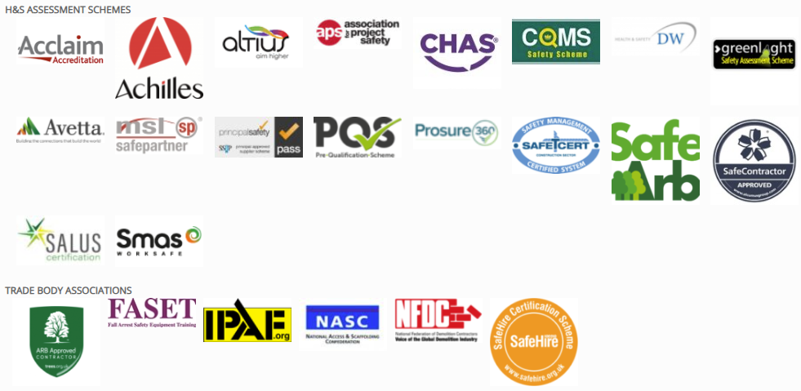
Statement from the Health and Safety Executive (HSE)
“SSIP assessments are all based on core criteria approved by the Health & Safety Executive (HSE). These core criteria describe what is required for a construction business to comply with basic health and safety law. The Core Criteria were originally published by HSE and the SSIP Forum has adopted the Core Criteria, with our agreement, to become part of the SSIP Rules and Bylaws.
HSE’s message for Clients, those who are procuring the services of suppliers to do construction work, is simple. HSE encourages Clients to accept valid certification, based on assessment by any SSIP Forum Member assessment Scheme as having met the Core Criteria, and that Clients should not then require any further evidence at the prequalification assessment stage.”
*Note: the Constructionline scheme does not carry out health and safety assessments.

As such, I would appreciate it if you would recognise my current assessment by (SSIP member scheme B or certification to SSIP member ISO 45001), which shows that an acceptable basic health and safety assessment has already been achieved and which can be verified on the SSIP Portal.
I trust the above is helpful.
I would appreciate it if you would, on consideration of the above, confirm that I am not required to join [insert name of scheme provider A] and that my current assessment by another SSIP member scheme (and which is recognised by (insert name of scheme provider A)) meets your needs at this stage.
Thank you for your consideration and co-operation in this matter.
If you require further information about SSIP please go to www.ssip.org.uk where you will find the most up to date list of Registered Members.

Yours sincerely,

